Bryce Huston

  30003673

Web programming Documentation

Contents

PEAR: 2

Identify potential software risks or problems, e.g. possible invalid user inputs that cause unexpected behaviour? Is requirements incomplete? Security issues? 3

Test and validate with sample inputs with screenshots. Test the logic of the contents of the application. Validate the consistency between the code and the software design. Include testing in various browsers, e.g. Chrome and Firefox. 4

Provide an evidence that you adjusted your application base on the test. 7

# PEAR:

#### Search.php



#### Topten.php

#### Graph.php



Connect.php

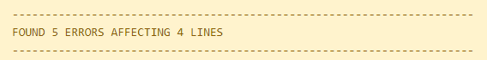

# Identify potential software risks or problems, e.g. possible invalid user inputs that cause unexpected behaviour? Is requirements incomplete? Security issues?

Regex scans for bad user input and displays an error message when necessary or else displays the chart with no data. The title field however does not have any exception handling scans as some movies contain high amounts of characters. I also removed the “required” code in my html as some searches may be from one field or multiple fields. The requirements are complete and laid out in an appealing theme. There are no security issues as I have been able to determine that through testing and PDO and regex statement handle mostly everything.

## Test and validate with sample inputs with screenshots. Test the logic of the contents of the application. Validate the consistency between the code and the software design. Include testing in various browsers, e.g. Chrome and Firefox.

### Chrome:

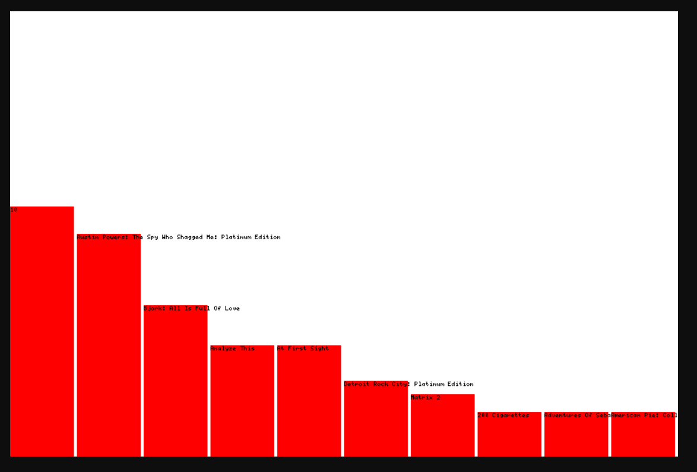

### Brave:

### Edge:

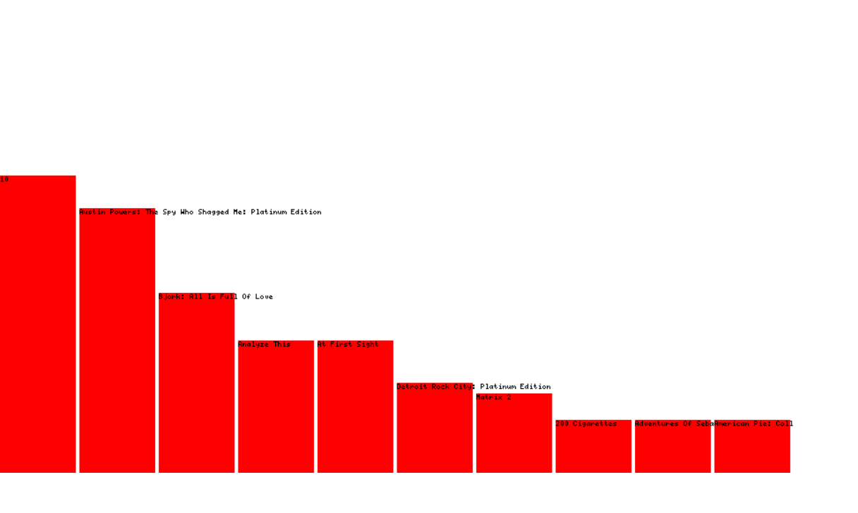

# Provide an evidence that you adjusted your application base on the test.

From testing originally I noticed my tables didn’t have any lines through it making it hard to read between the different categories. Simply adding “td” after “table” & adding border: solid black, I was able to quickly fix this

